Practise Test for Chapters 7-9

Multiple Choice | 10
Short Answer | 35
Extended Answer | 10
Total | 55
________________________________________________________________

You have 50 minutes to complete this assessment task.
You will need: pen, pencil, correction fluid, eraser
___________________________________________________________________________

Instructions
Use a blue or black pen, or a B or 2B pencil
For each question shade the box to indicate your answer
For example, if A is your response: □ A □ B □ C □ D

Marks will not be deducted for incorrect answers.
No marks will be given if more than one answer is completed for any question.
If you make a mistake, erase or cross out the incorrect answer. Do not use correction fluid.
____________________________________________________________________

1. □ A □ B □ C □ D  2. □ A □ B □ C □ D  3. □ A □ B □ C □ D  4. □ A □ B □ C □ D  5. □ A □ B □ C □ D | 6. □ A □ B □ C □ D  7. □ A □ B □ C □ D  8. □ A □ B □ C □ D  9. □ A □ B □ C □ D  10. □ A □ B □ C □ D
Part A: Multiple Choice – 10 questions [10 marks]

- Which one of the following statements about the function of blood is NOT correct?

- Blood transports waste products away from areas of high concentration.
- Blood transports nutrients away from areas of high concentration
- Blood provides readily available energy in the form of ATP to cells
- Blood contains cell fragments capable of initiating damage repair to capillaries

- Below is a diagram showing three components of blood.

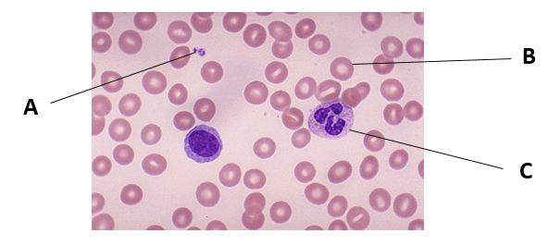

What is the function of the blood component labelled C?

- Transport nutrients, such as glucose, around the body to supply body cells.
- Remove dead or injured cells and invading organisms.
- Important role in blood clotting.
- Transport gases, such as oxygen and carbon dioxide, to and from body cells.

- Capillaries connect arteries to veins to maintain a continuous blood supply. Capillaries:

- are one cell thick and allows nutrients to move into the cells.
- are one cell thick that allows carbon dioxide to move from the plasma into muscle cells.
- contain smooth muscle and can undergo vasoconstriction.
- carry deoxygenated blood to the body tissues.

- In the diagram below, the heart chambers and the main blood vessels are numbered.

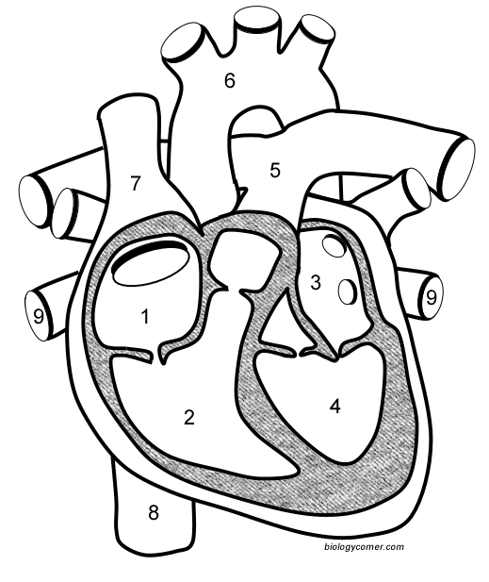

The right atria are numbered:

- 1 and 2
- 2 and 4
- 1 and 3
- 3 and 4

- The process of breathing air into and out of the lungs is called

- ventilation.
- inhalation.
- exhalation.
- gas exchange.

- The trachea is comprised of rings made of ________ that enable it to remain open and upright.

- bone
- muscle
- fat
- cartilage

- During expiration, air is flowing out of the lungs because:

- inspiration has just occurred.
- the chest wall is being expanded.
- the epiglottis has closed off the trachea.
- the air pressure in the lungs is more than atmospheric pressure.

- What is the principle function of the large intestine?

- Storage of faeces
- Absorption of digested food
- Absorption of water
- Digestion of cellulose

- Which of the following does NOT provide a physical means to digest food?

- Peristalsis
- Enzymes
- Teeth
- Churning

- The table below indicates in which part of the digestive system a particular food is chemically digested (indicated by the presence of a ‘+’ )
Section of digestive tract | Food 1 | Food 2 | Food 3 | Food 4
Mouth | +
Stomach |  | +
Small Intestine | + | + | +

Which of the foods shown above would most likely be a protein?

- Food 1
- Food 2
- Food 3
- Food 4

Part B: Short answer – 4 questions [35 marks]

- The diagram below shows the pathway of blood between the heart, lungs and other body organs.
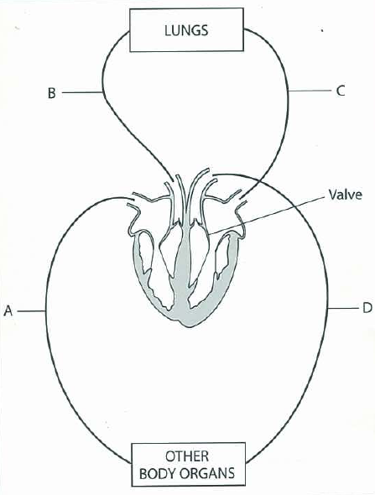

- There are two types of blood vessels bringing blood to and taking it away from the heart – arteries and veins.
Identify TWO structural differences between arteries and veins and relate these to the function. [4 marks]

- ____________________________________________________________________________________________________________________________________________________________________________________

- ____________________________________________________________________________________________________________________________________________________________________________________

- Name the blood vessels labelled B and C. [2 marks]

B _______________________________________________

C _______________________________________________

- Draw arrows on the diagram to show the direction of blood flow in the blood vessels labelled A and D. [1 mark]

- During a heart dissection, a group of students were overheard saying:
‘the left side of the heart is thicker because it pumps more blood’
Is this an accurate statement? Explain. [2 marks]

__________________________________________________________________________________________________________________________________
__________________________________________________________________________________________________________________________________

- One heart beat is made up of periods of relaxation (diastole) and contraction (systole) of the heart muscle. This occurs in a cyclical pattern of many heart beats called the cardiac cycle.
State the condition (open / closed) of the aortic and pulmonary semilunar valves and the atrioventricular valves during ventricular systole. [2 marks]

Semilunar valves ______________________________________________

Atrioventricular valves ______________________________________________

- Two important substances transported around the body in the blood pumped by the heart are oxygen and carbon dioxide.
Complete the table below about the modes of transport of oxygen and carbon dioxide around the body. [4 marks]

 | PERCENTAGE | METHOD
OXYGEN |  | Dissolved in plasma
OXYGEN |  | Bound to haemoglobin - oxyhaemoglobin
CARBON DIOXIDE | 8% | Dissolved in plasma
CARBON DIOXIDE | 22%
CARBON DIOXIDE | 70%

- The diagram below is the view through a microscope of the inside of the lungs.

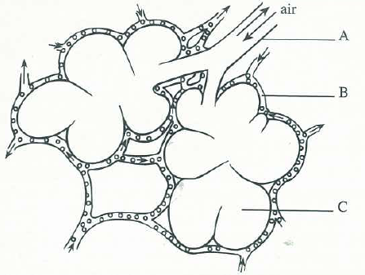

- Label the following structures: [2 marks]

A ______________________________________

C ______________________________________

- On the diagram above, use two different coloured arrows to show the direction of movement of oxygen and carbon dioxide during gas exchange. [1 mark]

Oxygen ______ Carbon dioxide ______ (record your colours here)

- Why does carbon dioxide move in this direction? [2 marks]

________________________________________________________________________________________________________________________________________________________________________________________________________________________________________________________

- The structures labelled C are specially designed to perform their function of gas exchange.
Identify ONE structural features of C and explain how that feature enhances the efficiency of C. [2 marks]

Structure feature | How does it enhance efficiency
- Annotate the diagram below showing what changes occur in the diaphragm and intercostal muscles that lead to inspiration. [4 marks]

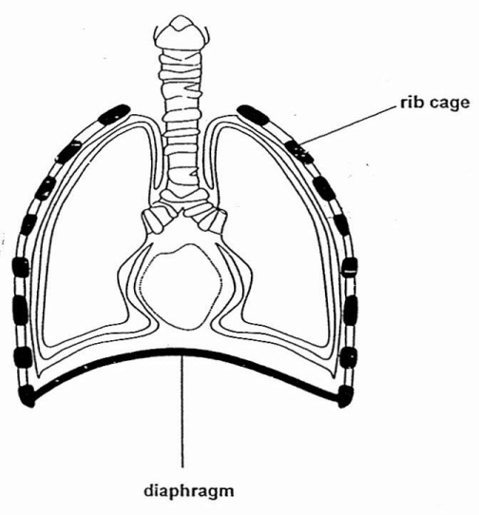

- During exercise, you would expect a person’s breathing rate to increase. Outline ONE reason why an increase in breathing rate is necessary. [2 marks]

__________________________________________________________________________________________________________________________________________________________________________________________

- The table below shows the percentage (%) composition of various gases in inhaled air.
Use the following terms to complete the table above to show the difference between inhaled and exhaled air: more; less; the same [2 marks]

Type of air | Percentage (%) amount of gas
Type of air | Oxygen | Carbon Dioxide | Nitrogen
Inhaled | 20.93 | 0.03 | 79.04
Exhaled

- The figure below shows a section of the digestive system.

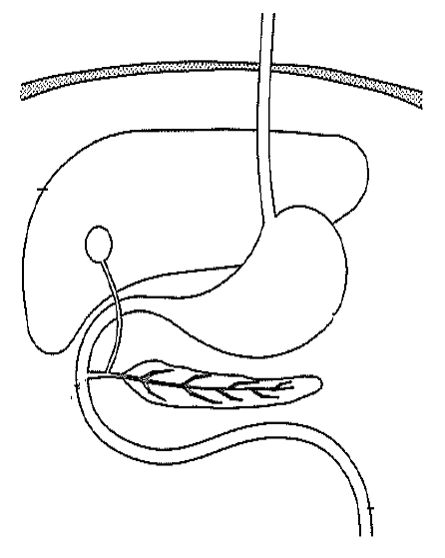

Bile is a substance produced in one place and stored in another. Both of these locations are shown on the above diagram.

- On the diagram above: [2 marks]

  - Label the organ where bile is produced (use one colour)
  - Label the organ where bile is stored (use a different colour)

- Identify what type/s of food bile breaks down. [1 mark]

_________________________________________________________________

- Explain why the action of bile is a form of mechanical digestion and not a form of chemical digestion. [2 marks]

____________________________________________________________________________________________________________________________________________________________________________________________________________________________________________________________________

Part C: Extended answer – 1 question [10 marks]

Exchange of materials between the external environment and the body’s internal environment occurs at specific places in the body. One of these places is the small intestine.

Use a simple diagram to assist your explanation of the features of the small intestine that maximises its efficiency in the absorption of nutrients.

____________________________________________________________________________________________________________________________________________________________________________________________________________________________________________________________________________________________________________________________________________________
____________________________________________________________________________________________________________________________________________________________________________________________________________________________________________________________________________________________________________________________________________________
____________________________________________________________________________________________________________________________________________________________________________________________________________________________________________________________________________________________________________________________________________________
____________________________________________________________________________________________________________________________________________________________________________________________________________________________________________________________________________________________________________________________________________________
____________________________________________________________________________________________________________________________________________________________________________________________________________________________________________________________________________________________________________________________________________________
____________________________________________________________________________________________________________________________________________________________________________________________________________________________________________________________________________________________________________________________________________________
____________________________________________________________________________________________________________________________________________________________________________________________________________
____________________________________________________________________________________________________________________________________________________________________________________________________________________________________________________________________________________________________________________________________________________
____________________________________________________________________________________________________________________________________________________________________________________________________________
____________________________________________________________________________________________________________________________________________________________________________________________________________
____________________________________________________________________________________________________________________________________________________________________________________________________________________________________________________________________________________________________________________________________________________
____________________________________________________________________________________________________________________________________________________________________________________________________________
____________________________________________________________________________________________________________________________________________________________________________________________________________
____________________________________________________________________________________________________________________________________________________________________________________________________________________________________________________________________________________________________________________________________________________
________________________________________________________________________________________________________________________________________
Part A: Multiple Choice – 10 questions [10 marks]

- Which one of the following statements about the function of blood is NOT correct?

- Blood transports waste products away from areas of high concentration.
- Blood transports nutrients away from areas of high concentration
- Blood provides readily available energy in the form of ATP to cells
- Blood contains cell fragments capable of initiating damage repair to capillaries

- Below is a diagram showing three components of blood.
What is the function of the blood component labelled C?

- Transport nutrients, such as glucose, around the body to supply body cells.
- Remove dead or injured cells and invading organisms.
- Important role in blood clotting.
- Transport gases, such as oxygen and carbon dioxide, to and from body cells.

- Capillaries connect arteries to veins to maintain a continuous blood supply. Capillaries:

- are one cell thick and allows nutrients to move into the cells.
- are one cell thick that allows carbon dioxide to move from the plasma into muscle cells.
- contain smooth muscle and can undergo vasoconstriction.
- carry deoxygenated blood to the body tissues.

- In the diagram below, the heart chambers and the main blood vessels are numbered.

The right atria are numbered:

- 1 and 2
- 2 and 4
- 1 and 3
- 3 and 4

- The process of breathing air into and out of the lungs is called

- ventilation.
- inhalation.
- exhalation.
- gas exchange.

- The trachea is comprised of rings made of ________ that enable it to remain open and upright.

- bone
- muscle
- fat
- cartilage

- During expiration, air is flowing out of the lungs because:

- inspiration has just occurred.
- the chest wall is being expanded.
- the epiglottis has closed off the trachea.
- the air pressure in the lungs is more than atmospheric pressure.

- What is the principle function of the large intestine?

- Storage of faeces
- Absorption of digested food
- Absorption of water
- Digestion of cellulose

- Which of the following does NOT provide a physical means to digest food?

- Peristalsis
- Enzymes
- Teeth
- Churning

- The table below indicates in which part of the digestive system a particular food is chemically digested (indicated by the presence of a ‘+’ )
Section of digestive tract | Food 1 | Food 2 | Food 3 | Food 4
Mouth | +
Stomach |  | +
Small Intestine | + | + | +

Which of the foods shown above would most likely be a protein?

- Food 1
- Food 2
- Food 3
- Food 4
Part B: Short answer – 4 questions [35 marks]

- The diagram below shows the pathway of blood between the heart, lungs and other body organs.

- There are two types of blood vessels bringing blood to and taking it away from the heart – arteries and veins.
Identify TWO structural differences between arteries and veins and relate these to the function. [4 marks]

MUST have comparison for the mark – cannot just say what arteries have and not veins
Structural difference | Relates to function
Arteries have thick/muscular/elastic walls, whereas, veins have thinner/less muscular/less elastic walls [1]  WALLS! are thick/elastic – NOT the artery or the vein itself | Arteries under high pressure from the pumping heart, veins are not [1]  OR  Vasodilation/vasoconstriction to direct blood flow
Veins have valves, whereas, arteries do not have valves [1] | Prevent back flow of blood to help veins transport blood back to the heart [1]

Each dot point space on the test paper was for ONE comparison ie. arteries have this, whilst veins have that, because …

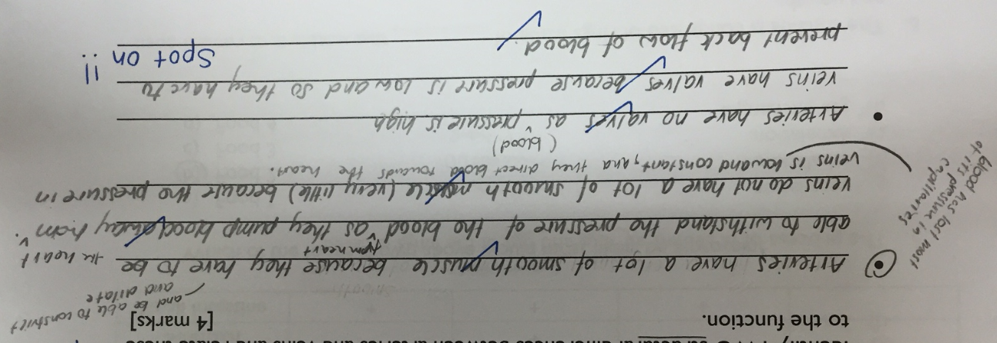

- Name the blood vessels labelled B and C. [2 marks]

B Pulmonary artery

C Pulmonary vein/s
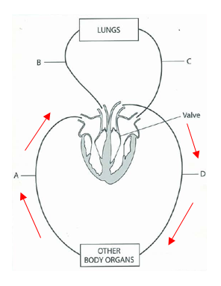
- Draw arrows on the diagram to show the direction of blood flow in the blood vessels labelled A and D. [1 mark]

Both arrows must be correct for [1] mark

- During a heart dissection, a group of students were overheard saying:
‘the left side of the heart is thicker because it pumps more blood’
Is this an accurate statement? Explain. [2 marks]

No -Pumps similar volume to the right side of the heart / does not pump more blood [1] MUST elaborate rather than just saying ‘No’
Pumps blood further distance than the right side of heart [1]
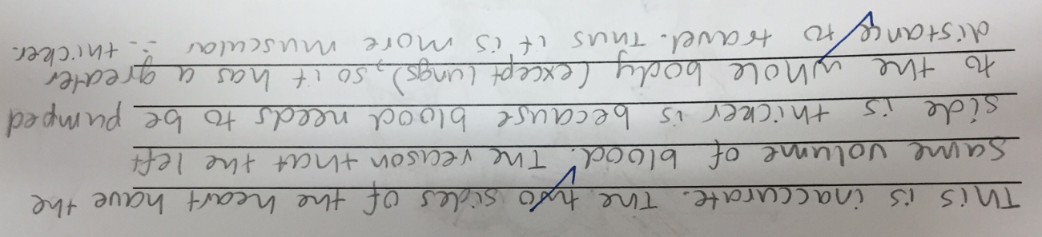

- One heart beat is made up of periods of relaxation (diastole) and contraction (systole) of the heart muscle. This occurs in a cyclical pattern of many heart beats called the cardiac cycle.

- State the condition (open / closed) of the aortic and pulmonary semilunar valves and the atrioventricular valves during ventricular systole. [2 marks]

Semilunar valves Open [1]

Atrioventricular valves Closed [1]

- Two important substances transported around the body in the blood pumped by the heart are oxygen and carbon dioxide.
Complete the table below about the modes of transport of oxygen and carbon dioxide around the body. [4 marks]

 | PERCENTAGE | METHOD
OXYGEN | 3% | Dissolved in plasma
OXYGEN | 97% | Bound to haemoglobin - oxyhaemoglobin
CARBON DIOXIDE | 8% | Dissolved in plasma
CARBON DIOXIDE | 22% | Bound to haemoglobin / carbaminohaemoglobin
CARBON DIOXIDE | 70% | As bicarbonate ions

- The diagram below is the view through a microscope of the inside of the lungs.

- Label the following structures: [2 marks]

A Bronchiole
C Alveoli

- On the diagram above, use two different coloured arrows to show the direction of movement of oxygen and carbon dioxide during gas exchange. [1 mark]

Oxygen ______ Carbon dioxide ______ (record your colours here)

Both arrows must be correct for [1] mark
MUST show exchange of gases between alveoli and blood, NOT just air moving in and out

- Why does carbon dioxide move in this direction? [2 marks]

Higher concentration of carbon dioxide in blood/plasma/erythrocytes than in the lungs/alveoli [1] ie. Clearly describe a diffusion gradient that exists between the blood and alveoli

Carbon dioxide diffuses across [1] MUST say diffuse or 0
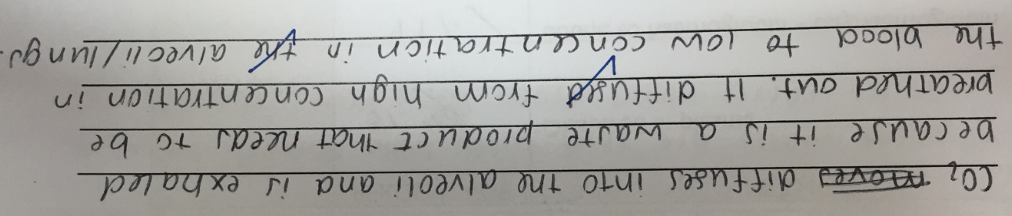

- The structures labelled C are specially designed to perform their function of gas exchange.
Identify ONE structural features of C and explain how that feature enhances the efficiency of C. [2 marks]

Structure feature [1] | How does it enhance efficiency [1]
Alveoli give the lungs their huge surface area to volume ration  *Shape/size/number - same | Large amount of gases can be exchanged
Each alveolus surrounded by capillary network | Ensures continuous flow of blood, helping to maintain a concentration gradient for oxygen/carbon dioxide
The walls of the alveoli are very thin/1 cell thick | Gas molecules do not have far to travel
Covered in a thin layer of moisture | Gases diffuse when dissolved in solution

NOT: ‘makes diffusion of gases easier/more efficient’ – need to be specific in how it makes it easier/more efficient

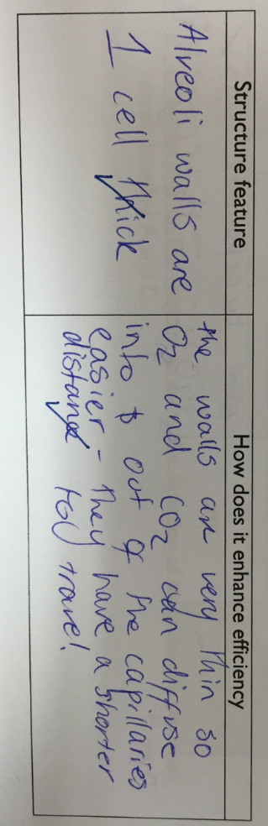

- Annotate the diagram below showing what changes occur in the diaphragm and intercostal muscles that lead to inspiration. [4 marks]

MUST link the contraction of the muscles with the movement they cause – we were a little generous here – you must make it obvious and clear for the marker that “this causes that”, it is NOT up to the marker to ‘fish’ for your links/answers.

Diaphragm CONTRACT [1] and moves DOWNWARDS [1]
Intercostal muscles CONTRACT [1] moving ribs UP and OUT [1]

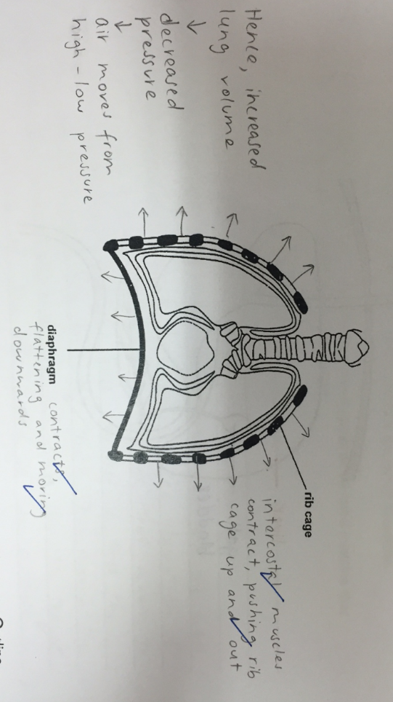

- During exercise, you would expect a person’s breathing rate to increase. Outline ONE reason why an increase in breathing rate is necessary. [2 marks]

Remove extra carbon dioxide [1] produced due to increased cellular respiration [1]
OR
Supply body cells with more oxygen [1] to support increased cellular respiration [1]
MUST mention cellular respiration
- The table below shows the percentage (%) composition of various gases in inhaled air.

Use the following terms to complete the table above to show the difference between inhaled and exhaled air: more; less; the same [2 marks]
[-1] mark for each incorrect label

READ THE QUESTION – if you write actual values, you were incredibly lucky to be awarded any marks – this will not be the case in future assessments, especially NOT the WACE

Type of air | Percentage (%) amount of gas
Type of air | Oxygen | Carbon Dioxide | Nitrogen
Inhaled | 20.93 | 0.03 | 79.04
Exhaled | less | more | same

- The figure below shows a section of the digestive system.

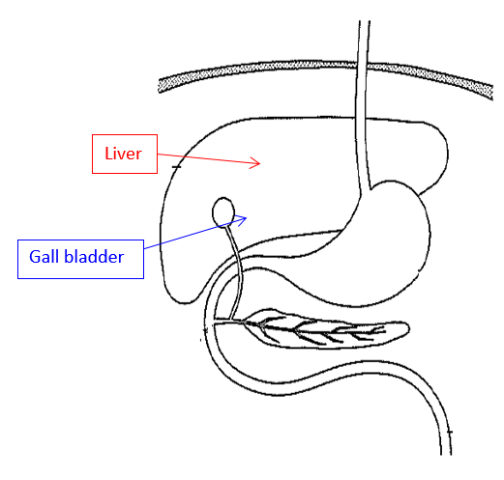
Bile is a substance produced in one place and stored in another. Both of these locations are shown on the above diagram.

- On the diagram above: [2 marks]

- Label the organ where bile is produced (use one colour)

- Label the organ where bile is stored (use a different colour)

- Identify what type/s of food bile breaks down. [1 mark]

Fats / lipids

- Explain why the action of bile is a form of mechanical digestion and not a form of chemical digestion. [2 marks]

Mechanical – breaks fat into smaller units of same substance [1] big blobs small droplets

Chemical – actually changes substance – bile does NOT do this [1]
MUST include comment on what chemical digest does and/or why bile is NOT chemical digestion

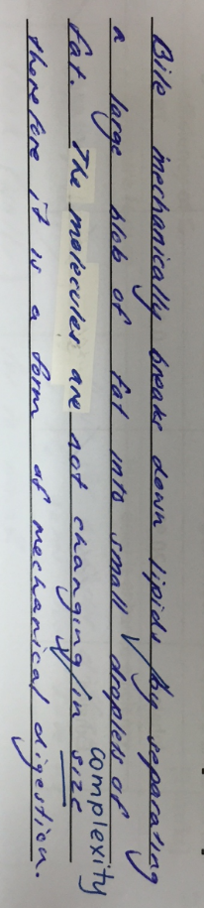

Part C: Extended answer – 1 question (10 marks)

Exchange of materials between the external environment and the body’s internal environment occurs at specific places in the body. One of these places is the small intestine.

Use a simple diagram to assist your explanation of the features of the small intestine that maximises its efficiency in the absorption of nutrients.

Diagram included and fully labelled [1]

Diagram used in response [1] – annotated or numbered to correspond with features – if not, then no marks

4 x structural features and their explanation:
[1] Structural feature – well defined and accurate

[1] How it helps with absorption – well explained and accurate

Structural feature  MUST be a structural feature – NOT ‘big surface area to volume ratio’ | How does it enhance efficiency?  MUST be explicit – NOT ‘it makes absorption easier/faster’ – really need to explain exactly how the feature helps with absorption
Small intestine is extremely long | Plenty of time and opportunity for nutrients to be absorbed from small intestine into blood
Lined with many villi | = Increased surface area to volume ratio that heaps of nutrients can be absorbed at any one time / in a short amount of time
Covered with microvilli | = Increased surface area to volume ratio that heaps of nutrients can be absorbed at any one time / in a short amount of time
Each villi is well supplied with blood vessels / contains a lacteal | = Maintains concentration gradient ensures continuous and fast absorption of nutrients into blood / lymph
The wall of villi is one cell thick | Nutrients do not have far to travel into blood/lymph
Villi are always swaying due to muscle movement in intestinal wall | Villi are made to contact the intestinal products to enable nutrients to be absorbed
Lined with absorptive cells | Enable nutrients to be absorbed into villus

