Internal non-specific defences
Phagocytes
- Cells that engulf and digest micro-organisms and cell debris
- Important in defence against disease
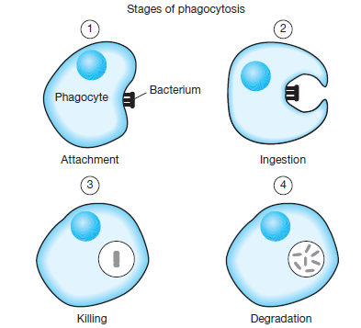

- Leukocytes are a type of white blood cell that carry out phagocytosis
- Can leave bloodstream and migrate to site of infection in tissues
- Can secrete substances that destroy bacteria before engulfing them or engulf live bacteria and digest them
- Many types of leukocytes
- Macrophages develop from leukocytes

Macrophages
- Large, phagocytic cells
- Some “patrol” body for pathogens, others remain fixed in place
- Can secrete substances that destroy bacteria before engulfing them or engulf live bacteria and digest them
- Eliminate pathogens before infection spreads

Inflammatory response
- Response to damage of tissues
- Reduces spread of pathogens, destroy them and prevent additional ones
- Removes damaged tissue and cell debris
- Begins to repair damaged tissue

Test Questions
c) The mosquito bite itself will stimulate the inflammatory response. State one cause of each of the four signs of inflammation ‘redness, swelling, heat and pain’. [4 marks]
Sign of inflammation | Physiological cause
Redness
Swelling
Heat
Pain

4. Which of the following are key characteristics of a fever;
i. The body’s thermostat is reset at a lower level
ii. The body’s thermostat is reset at a higher level
iii. High body temperature inhibits the growth of bacteria and viruses
iv. The person can still feel cold due to regulation around a higher body temperature.
- iii and iv only
- i and iv only
- ii, iii and iv
- i, iii and iv

5. Which of the following are NOT considered to be an external defence offered by the urogenital tract?
- Cerumen production.
- Mucous membranes.
- Acid secretions
- Flushing action of body fluids.

6. The purpose of inflammation is to
- reduce the spread of pathogens
- stop the movement of the infected area
- alert the body that there is a problem
- increase the spread of the pathogens

7. The process by which leukocytes ‘attack’ microorganisms is called
- pinocytosis
- exocytosis
- phagocytosis
- macrophage

8. Which of the following is not considered to be a non-specific defence against pathogens?
- The skin acting as an impervious barrier.
- Vomiting induced by a bacterial infection.
- Antibodies being produced by a B-lymphocyte.
- The inflammatory response.

Sign of inflammation | Physiological cause
Redness | (histamine causes) Increased blood flow to the area [1]  NOT: histamine increases permeability- this allows plasma to leak out (which results swelling).
Swelling | Escape of fluid into the area from blood/ plasma leaks out of more permeable capillaries [1]
Heat | Increased blood flow to the area [1]
Pain | Abnormal conditions stimulate pain receptors [1]  NOT: nerve endings

C, A, A, C, C

Fever
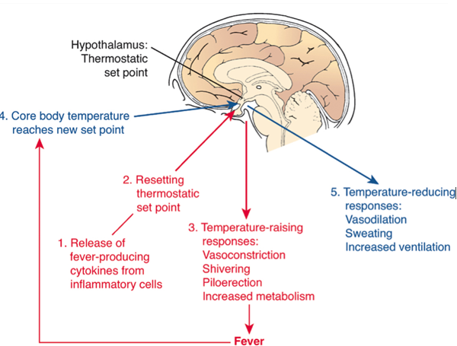

- Increase in body temperature in response to infection e.g. flu
- Hypothalamus resets body temperature to a new, higher level
- When you have a fever, body temperature is regulated in response to heat/cold at this higher set point

Rapid onset of fever:
- Hypothalamus resetting thermostat to higher level happens quickly so person feels cold
- To conserve and increase body heat person experiences:
  - Vasoconstriction in skin
  - Shivering
- Results in body temperature being driven up rapidly
- Breaking of fever = crisis
  - Body thermostat resets to normal set point

Benefits of fever
- Inhibition of bacteria and viruses
- Increase rate of chemical reactions (heat) for repair of cells
Negative effects of fever
- Body temperature gets too high, death can result (44.4 – 45.5⁰C)

Resetting thermostat
- Pyrogens – chemicals released by WBCs during inflammatory response act directly on hypothalamus thought to reset internal thermostat

