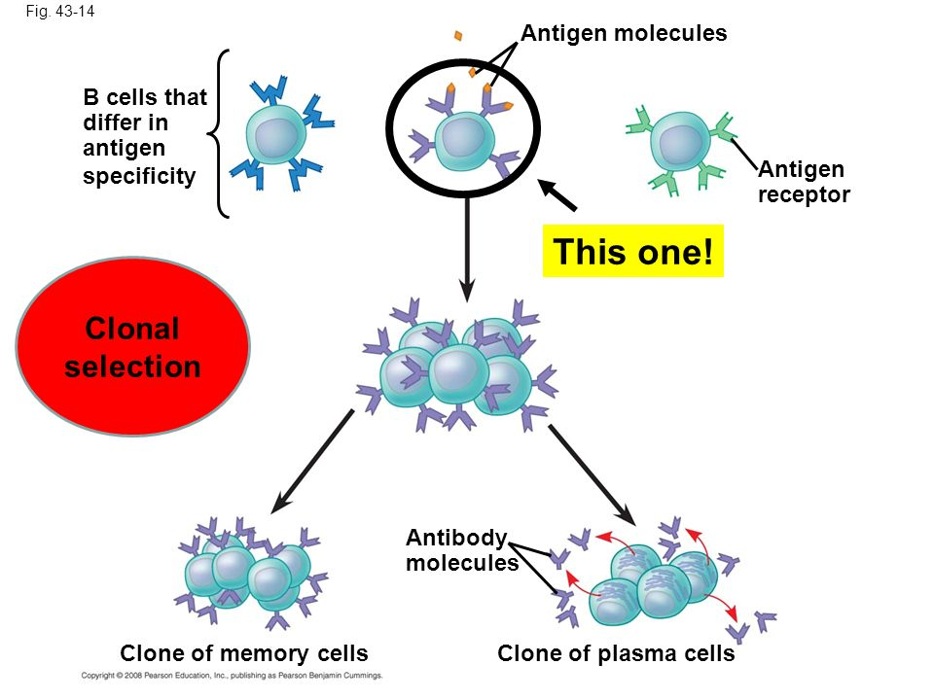
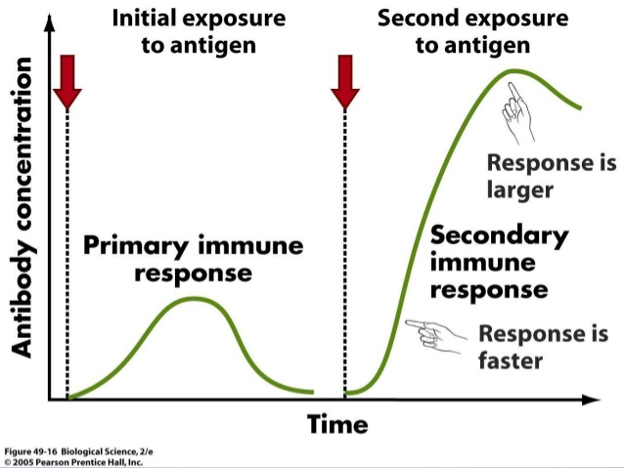

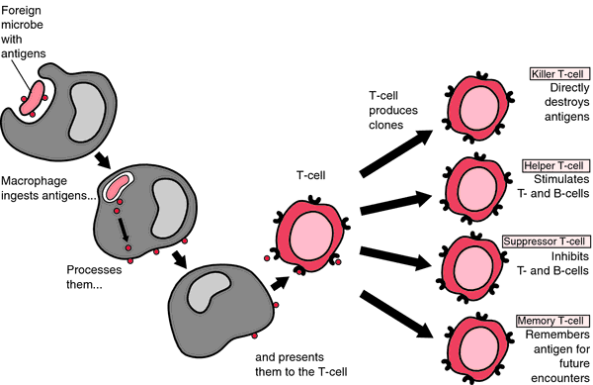

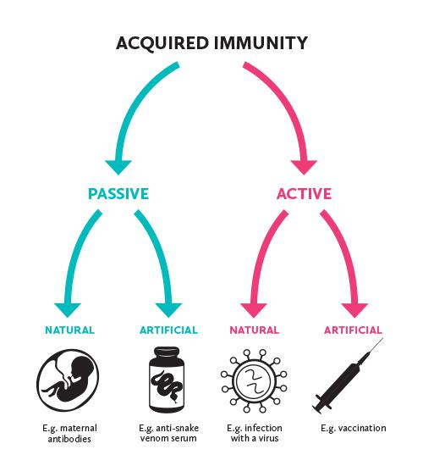

Exposure to antigens induces humoral response. Long lasting effects
No work is done on your part – you are given antibodies ready-made

No memory cells formed – effect is short lived
Naturally given to babies (initial protection)
Given to prevent serious diseases
Memory cells will remain in body – effects can last a person’s entire life.
This type of immunity is long lasting

